# Experimental testbed

Our experiment use the dataset of received signal strength indication (RSSI) collected from within an indoor office building. The office building environment is a single building measuring roughly 24*15.6 meters. The interior consists of three small offices, and a long hallway. The floor plan of this environment with measurement points and the base stations' locations labeled is provided in Figure 1. The black and yellow dots denote locations where empirical signal strength information being collected with grid width 3 meters and 5 meters respectively. This data captures RSSI behavior when 802.11 frames are transmitted using the device driver and the API we developed. To quantify how the transmitters received signal strength varies with their physical locations within this building, the experiment transmits 300 packets from each of the 78 physical positions.

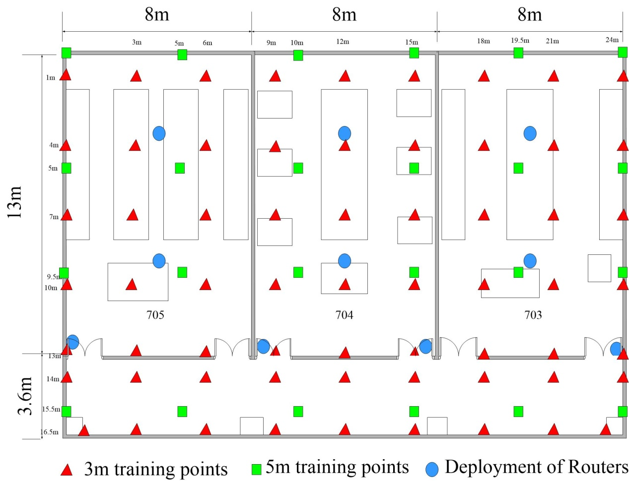

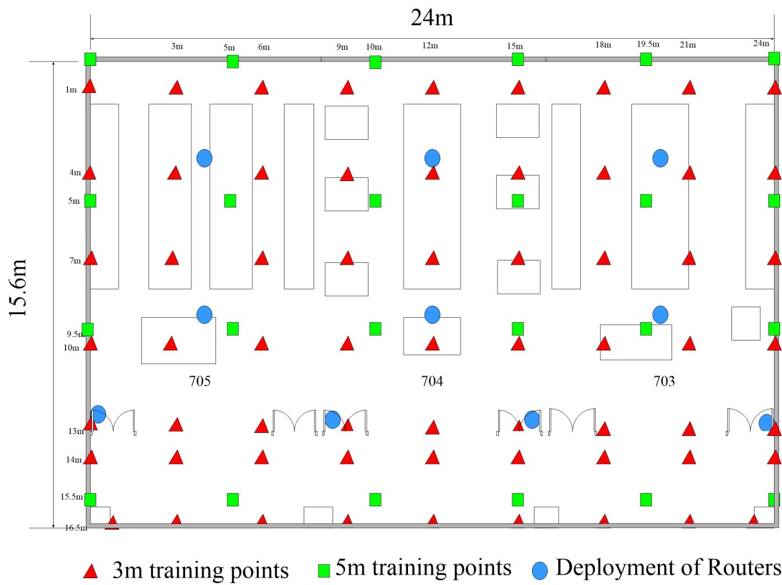

# Experimental Scenarios

We use the prototype to validate our method and measure practical performance. In particular, we select 18 phones with in this building as locating target, each of which has a RSSI during a time interval. There are 30 time interval altogether.

# Impact of communication distance

To investigate how the accuracy of location estimation would be impacted for different communication distances of indoor devices, we experiment various values and observed its effect on localization accuracy. Figure 2 shows the cumulative error distribution of our method for different value of communication distance. As is shown in the figure, for small communication distances (7m or smaller), it has an apparent influence on localization error. Particularly, when communication distance equal to 5, the localization is about 30% worse than when the communication distance larger than 8. In addition, for small communication distances, there always remains significant errors (4~6m). When the communication distance becomes larger than 8m, this impact gets very weak.

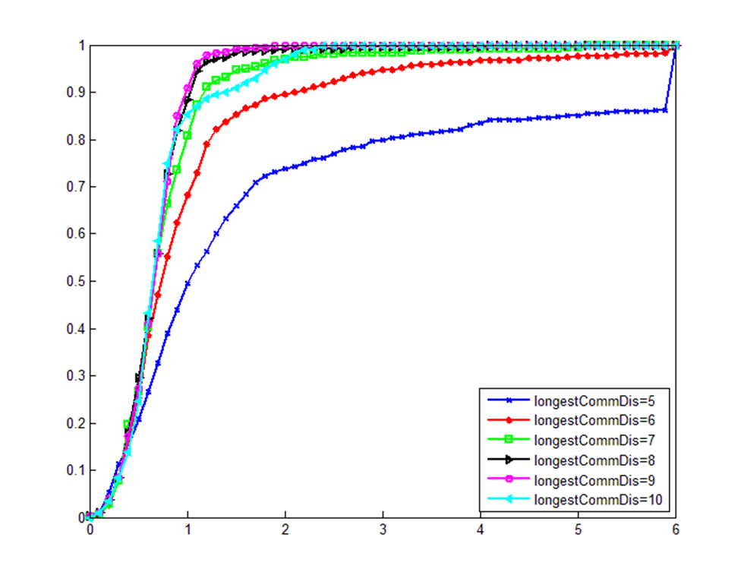

# Localization errors

We compare the performance of our method with the following existing localization scheme: Radar, Horus and PLWLS. Figure 3 shows the cumulative distribution of localization errors for the three schemes. Figure 3 summarizes the comparison results. From Figure 2, we observe that WiFi only localization (Radar and Horus) can result in significant error (6~8m). Adding distance constrains, our method helps eliminate these outliers. Comparing our method to the PLWLS system shows that the average error is decreased by 0.6m. These results show the effectiveness of the proposed techniques. Figure 4 shows that the mean error is decreased by more than 76% for Horus and 66% for PLWLS. The 50% error is decreased by more than 70% for the Horus system and 45% for PLWLS. The 80% error is decreased by more than 77% for the Horus system and 69% for PLWLS respectively.



